

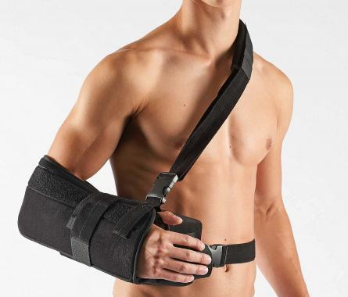

**Schulter abduction wedge**

**OR2C**

You will need the help of a second person to put this product on.

Make sure all Velcro fasteners are open.

Place the abduction wedge’s curved part on your body and fasten the body strap with the quick fastener. The body strap can be adjusted for width (Fig. 1).

Slide your arm into the arm cuff intended for this purpose and make sure that your elbow is pushed into the rear part of the pouch.

Close the arm cuff using the Velcro fastener (Fig. 2).

Place the shoulder strap on your healthy shoulder and close it using the quick fastener on the front of the arm cuff. Adjust the length of the shoulder strap in such a way that your arm is at a right angle and located in a comfortable position (Fig. 3).

Now, attach the arm cuff to the abduction wedge’s flat side using the Velcro fastener (Fig. 4).

To ensure optimum fit, you can re-adjust the Velcro fasteners.

Squeezing the enclosed ball promotes blood circulation in the injured arm.

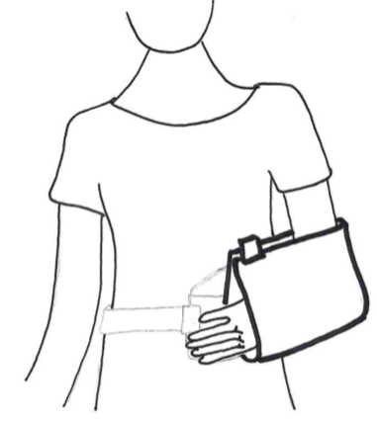

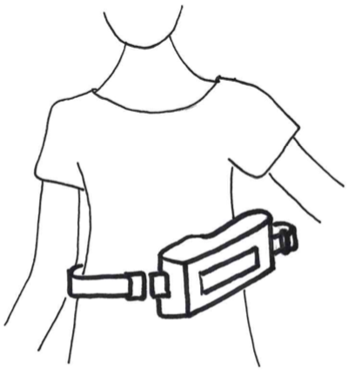

Fig. 1

Fig. 3



**Schaper Healthcare GmbH**

Vogelweiderstraße 146 |4600 Wels | Austria

[office@schaper-healthcare.at](mailto:office@schaper-healthcare.at) | [www.schaper-healthcare.at](http://www.schaper-healthcare.at)

T +43 7242 252 965

Version 08/2019

Note: All serious incidents connected to the product must be reported to the manufacturer.

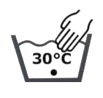

Indications:

Post reconstructive rotator cuff surgery, conservative treatment of anterior and posterior shoulder disclocations

Application instructions:

This product is solely intended to be used on one patient.

If you are unclear or have any questions about the product and its use, please contact your doctor or qualified personnel.

Storage instructions:

Don’t expose the product to direct sunlight. Store in a dry place protected from sunlight.

Disposal instructions:

This product can be disposed of in regular household waste.

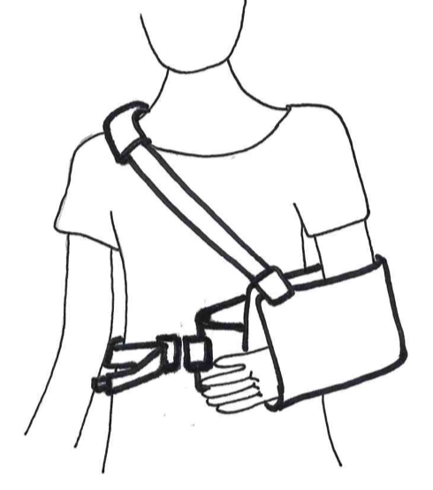

Fig. 4

Fig. 2

